Specialised exchange surfaces

The small intestine

- The products of digestion are absorbed into the bloodstream through the walls of the small intestine. Some absorption of the molecules is by diffusion. Diffusion is faster when there is a large surface area and it is a short distance for the molecules to travel.
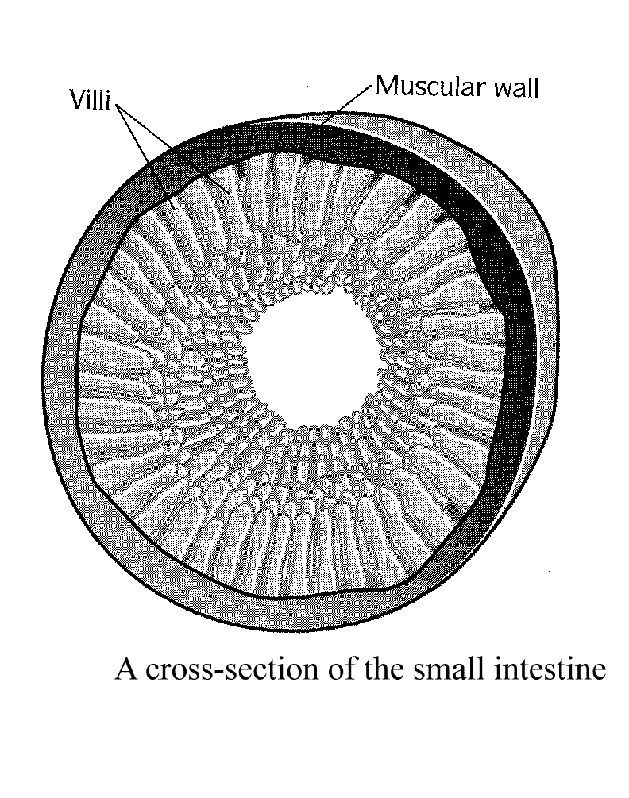
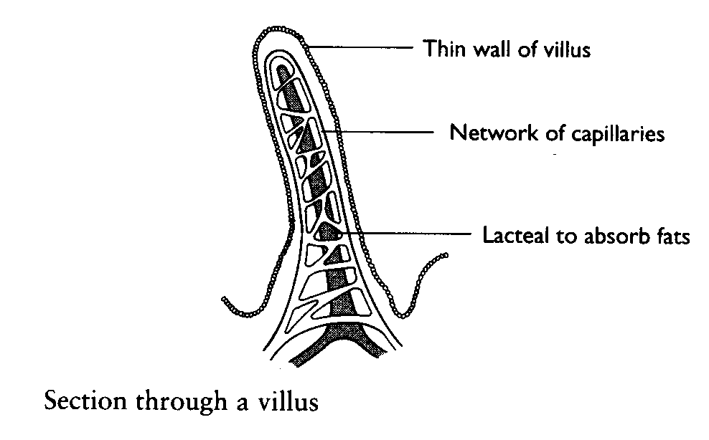

Look at the diagrams of the small intestine and of a villus.
The small intestine is very well adapted to absorb food.
Explain the advantages of each of the adaptations below

- The cells in the small intestine contain lots of mitochondria

__________________________________________________________________

__________________________________________________________________

- Its surface is covered with millions of villi

__________________________________________________________________

- The wall of the small intestine is only one cell thick

__________________________________________________________________

- Each villus has a good blood supply

__________________________________________________________________

The alveoli in the lungs

Label the diagram of the alveoli with these key features: capillary, red blood cells, thin alveoli wall, layer of moisture.

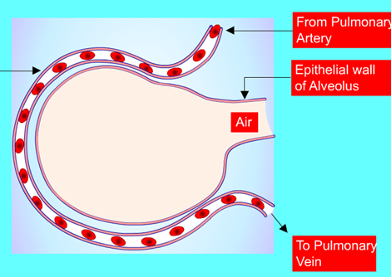

Explain the key features that allow gas exchange in the alveoli to occur quickly and efficiently.
_______________________________________________________________________
_____________________________________________________________________________________________________________________________________________________________________________________________________________________________________________________________________________________________________________________________________________________________________________________________________________________________________________________________________________________________________________________________________________________________________________________________________________________________________________________________________________________________________________________________________________________________________________________________________________

